Terahertz Wand

What is this used for?
The Terahertz Wand addresses circulation, revitalizes skin, and offers instant relief. Using small doses of infrared frequency and heat, the terahertz wand vibrates at frequencies, making healthy cells more resilient. The frequencies reduce and strengthen DNA and organic molecules, resonating with our cells enhancing self-repair.

How does this work?
Improving microcirculation allows your blood vessels to dilate, reducing blood flow resistance and viscosity. Blue light therapy activates inert cells absorbing with moderate temperature, thus eliminating dormant cells. When blood cells are healthy, blood circulation improves, your body can now effectively bring oxygen and nutrition to other cells. At the same time, flush away toxins and dead cells.

Is this safe to use?
Terahertz frequency is found between the far-infrared rays and the microwave energy. Within the last two decades, researchers have discovered benefits of Terahertz frequency on the human body. It is a wellness modality belonging to the category of Energy medicine. We have tested and proven our wand to show there is zero emission of radiation.

How to Use the Terahertz Wand
⬡ Blow directly on the skin, acceptable to blow through clothing.

⬡ It is best to drink two cups of warm water before and after blowing. For some this is not feasible, try to stay as hydrated as you are able.

⬡ Enjoy the process & be patient, allow time for your body to repair itself. Everyone should start slowly 2-5 minutes per area & low temperature settings, this helps your body avoid a healing crisis. Each day you can start to ease into increasing your time adding in higher heat options.

⬡ You can hold the wand near a glass of water to “charge” the water, this purifies the water and stays active for up to 24hrs.

⬡ When performing a full body protocol first (blowing your palms, feet, lymph areas, down your spine), blowing on your troubled or pained last then the process will be more effective.

⬡ It is best to avoid being cold for a few hours after therapy, do not eat cold food, and do not take a shower. You can turn on the fan and AC, but not too cold or blowing directly onto your body.

⬡ Recommended maximum use is two separate sessions each day no more than 30 minutes each.

⬡ Far infrared terahertz waves can penetrate 3-5 centimeters of skin

*Disclaimer* Avoid using around areas with bondage, stents, or metal.
Not recommended for use during menstrual cycles or those
with severe diseases (liver, heart, bleeding disorders, etc.)
High blood pressure- do not blow directly on your head
⬡ Instructions ⬡

Terahertz Wand
- Plug the Terahertz Wand into an electrical outlet.
- Switch the Power Button to On setting.
- Select your desired Light and Heat setting.
6.0 Red- 750 watts US 115v, features 4 infrared lights and 3 temperature settings: low cool, high cool, and high heat. Line up the indention on the barrel to the arrow icon on the wand handle, twist the barrel counter clockwise and lock onto the handle.
7.0 Red- 1,000 watts US 115v, features 4 infrared lights and 3 temperature settings: low heat, medium heat, and high heat. To assemble: Line up the arrow on the barrel with the unlock icon on the wand handle. Simply twist the barrel clockwise until it clicks (do not touch the clip). When removing the barrel, pull the clip down and rotate the barrel counter clockwise.
Pro Max Blue- 1,100 watts US 115v, features 6 infrared lights and 3 temperature settings: low heat, medium heat, and high heat. Hold down the power button for 3 seconds to turn on.
Use
- Drink 1 bottle of water (16 fl oz).
- Turn on the Terahertz Wand and set it to the desired settings.
- Hover the wand just above the skin's surface with the light pointing towards your body. Avoid direct skin-contact with the wand tip.
- Move the wand in small circular motions over each part of the body. Stop immediately if the area becomes inflamed.
- Drink 1 bottle of water (16 fl oz).
Safety
- Do not leave wand turned on or unattended without monitoring.
- Do not sleep with the wand turned on.
- Do not use it while in the bathtub or submerge the wand in water.
- When using a US plug in forgegin outlet, a converter is mandatory. An adapter is not able to convert the voltage as necessary.

The following routines are a more specific option on an as needed basis.
Start with about 2-5 minutes on each area before working your way up
from low settings to higher, low time to more time. Always start low and slow,
see how your body reacts first. Everyone's routine will differ as no one person has
the same amount of dormant cells or threshold. If at any point you feel a healing crisis, stop immediately to allow your body to recover. This is your body speaking
that the detoxification process is happening too quickly, always listen to your body and flush all toxins with water.

Headache: Related to the cervical spine, blow on the neck first then the head. Blow the entire shoulder and neck, then the ear lymph and head. (There might be improvement symptoms of headache or insomnia)

Hair problems: First blow on the neck and the entire back, then the kidneys, back and front of stomach and spleen area and then head.

Face: Blow on the neck, and the entire back to regulate the viscera, blow the face last. (do not blow directly on open eyes)

Eyes: Blow to the neck, back and liver area in the middle of the waist, and then blow on the eyes while closed. (detox could include dry eyes, itchy or other.)

Ear: First blow on the neck, waist and kidney area, then blow on the ears. (Frequent blowing on the ear can regulate visceral function)

Rhinitis/nasal problems: First blow on the neck area, front and rear lung areas, then blow around the nose.

Toothache/Oral ulcer: First blow the neck area, front and rear lung areas, then blow on the toothache/ulcer.

Sore throat/Cough: First blow on the neck area, front and back lung area, then blow on the entire throat and cervical lymphatics, last blow into the open mouth.

Cough and cold: Blow the entire back and neck, more on the spleen and stomach area, front and back lung areas. Last blow the entire throat.

Cold/runny nose: First blow on the neck and back, then on the front and back lungs area, lastly blow the nose.

Fever: Blow 5-7 minutes on palms, soles of feet, front chest, back, cervical spine and head.

Bronchitis/Asthma: First blow on the neck and back, then on the front and back of lungs area for, finally blow on the throat and nose.

Shoulder and neck problems: Blow the palms and soles of the feet, blow the neck and entire shoulder. Last, blow fingers and arms.

Spleen gastrointestinal physiotherapy: First blow on the neck and the entire back，more on the spleen and stomach area, and then blow on the front stomach and abdomen. (Do not use if gastric is bleeding)

Lower back pain: Blow the palm and soles of the feet, then blow the entire back and neck, finally blow on the area where it hurts.

Constipation, intestinal problems: First blow the entire back, more on the lung area, finally blow on the front entire belly.

Haemorrhoid’s therapy: To regulate the internal organs first blow the entire back, strengthen the lungs area, then blow on the hemorrhoids, last blow the palms and soles of the feet.

Regulate athlete's foot and onychomycosis: First blow on the back, strengthen the liver and gallbladder area, and then blow on the feet.

Skin problems: First blow the entire back, more on the lung area, and then blow on the skin problem areas. (During the process, the skin is itchier or blisters are healing effects)

Wound problem: Just blow the wound in circular motions 2-3 times a day (Not directly on an opened wound)

Insomnia and poor sleep: First blow on the shoulders, neck and back and then blow the entire head.

Inflammation of the tonsils (Sore throat): First blow on the shoulders and neck, then blow straight to the throat, blow in and away. (During the process, if you have fever and more nasal discharge, this is a normal effect)

Hyperthyroidism: First blow the back of neck, front and back liver area for 25 min, then blow the hyperthyroidism. (During the process; blisters, redness, and hotness may appear as normal detoxification recovery phenomena)

Varicose veins: First blow the palms and soles of the feet, then the entire back, more on the main nerves and lung area. Finally, blow on the varicose veins. (More itching or blisters are signs of improvement effects)

Gout conditioning: First blow the palms and soles of the feet, then blow the entire back more on the spleen, stomach, liver, gallbladder and kidney area, then blow the painful area. (Blisters, pain in other area is a sign of improvement)

Rheumatic joint pain: First blow on the palms and soles of the feet, then the entire back and then blow all the joints, more on the painful joints. (If blisters appear, more painful, it is an improvement effect)

Obesity/weight loss: First blow the palms and soles of the feet, then blow the entire back, more on the spleen, stomach, liver & gallbladder area and then blow on the front belly.

High blood pressure: First blow on the palm and outer of hand, then the sole and inner of feet, when better, blow downward on the back. (High blood pressure, do not blow on the head when first starting, blow downward on the back. When blown upward, you sweat more and blood circulation becomes rapid)

Blood sugar: First blow on the palm and outer side of the hand, then the sole and inner side of the foot, then blow on the middle of the front body from the chin to the bladder, top to bottom. (The time for low blood sugar should not be too long and pay attention to replenishing body energy)

Invigorate the kidney and yang: First blow on the palms and soles of the feet and then blow on the back, more on the center, kidneys and then navel.

Protocol How to?
Any order is acceptable
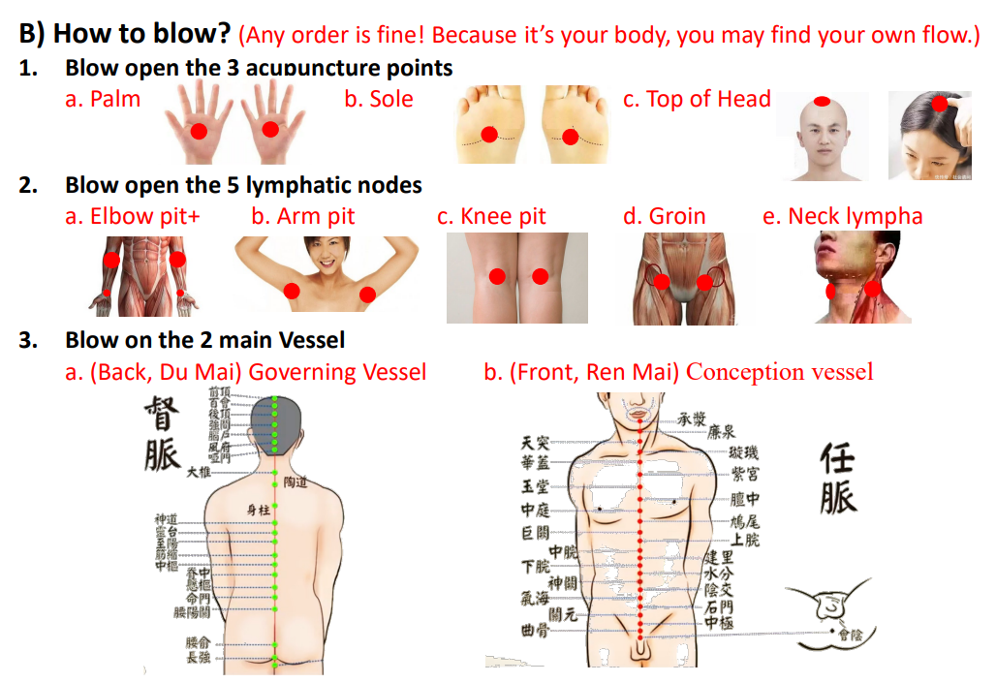
We have two main vessels: Your governing vessel can be accessed
by blowing directly down your spine. We hold the most dormant cells in our tailbone so this area is important to focus on, but also be more sensitive with. For the Conception Vessel, blow on the front of your body from the chin straight down to your lower abdomen.

